**Setting up mail server**

1. Go to <https://mailtrap.io/>
2. Click “sign up” button if you don’t have an account
3. Create a free account

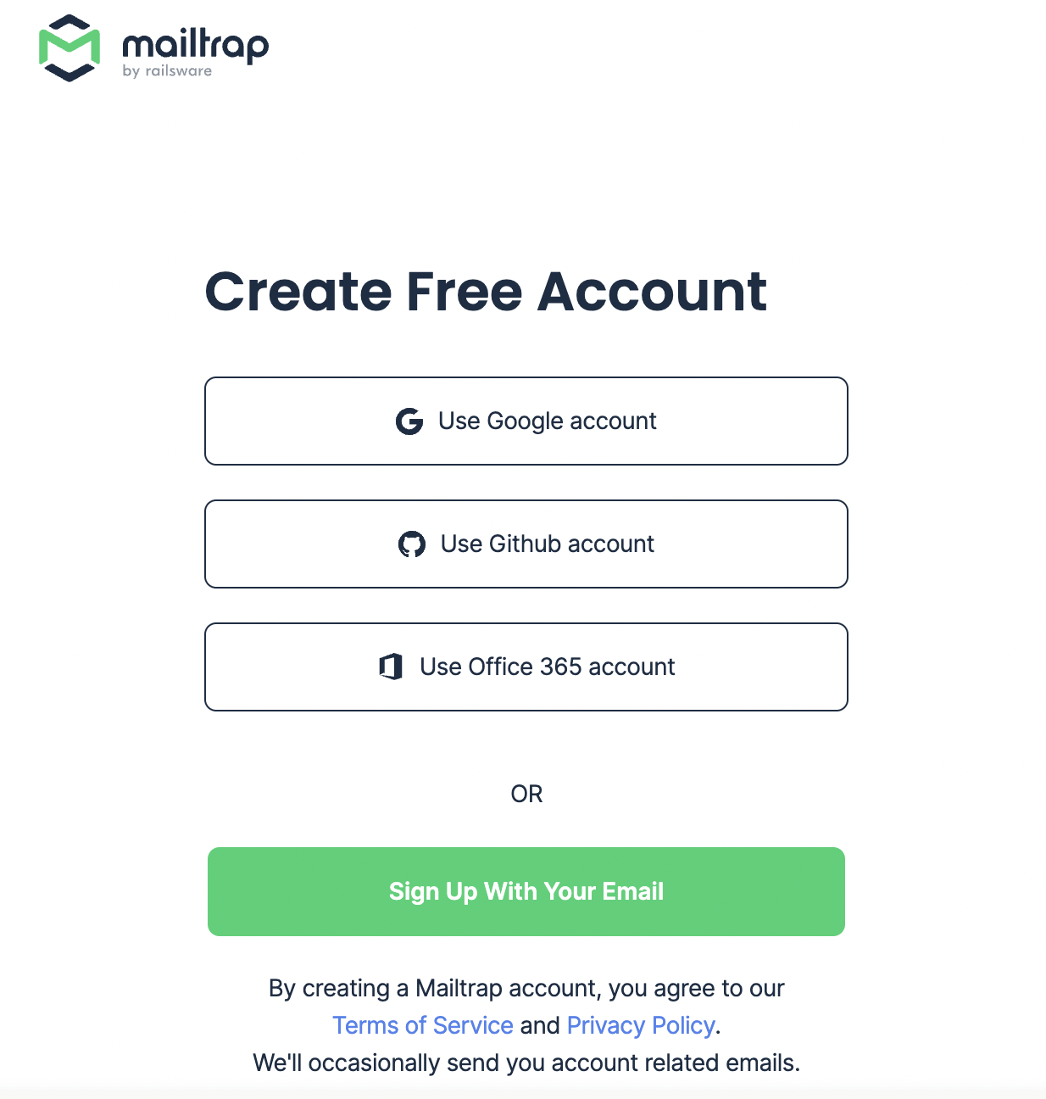

1. Go to Sandbox – inboxes at the side dashboard

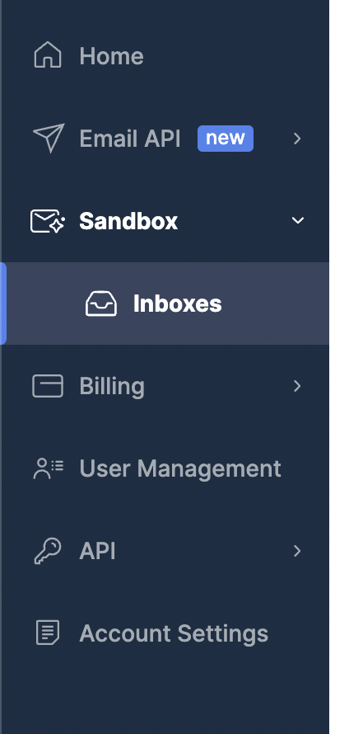

1. Click at the inbox you want to use
2. Go to SMTP settings

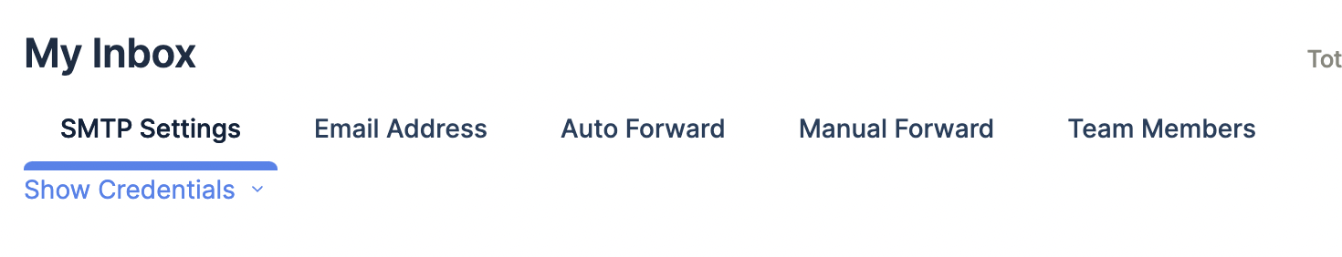

1. Choose Flask-Mail at Integrations

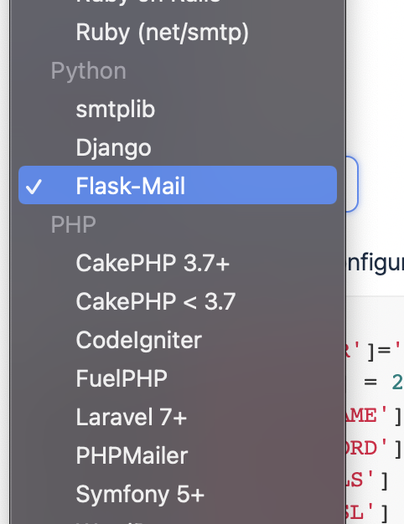

1. Copy the setting below and paste it to __init__.py under create_app()

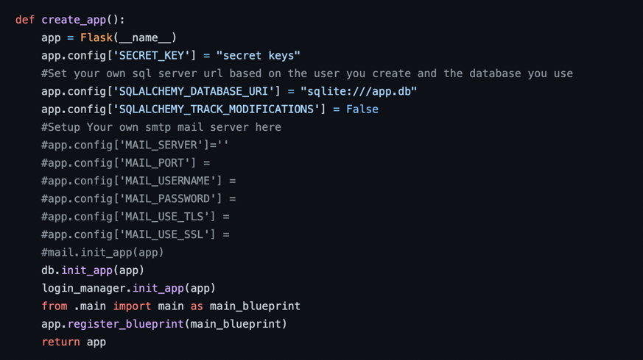

1. Uncomment the sending email function in view.py

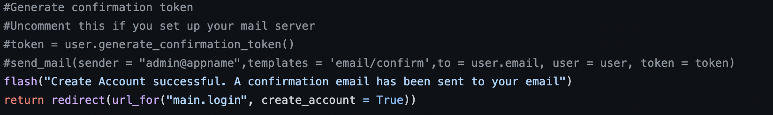

1. Run the app

**Setting up machine learning model**

1. Go and download model checkpoints

<https://drive.google.com/drive/folders/1e3pajKB8ogWH-BynGu3k2B6rOedngEma?usp=sharing>

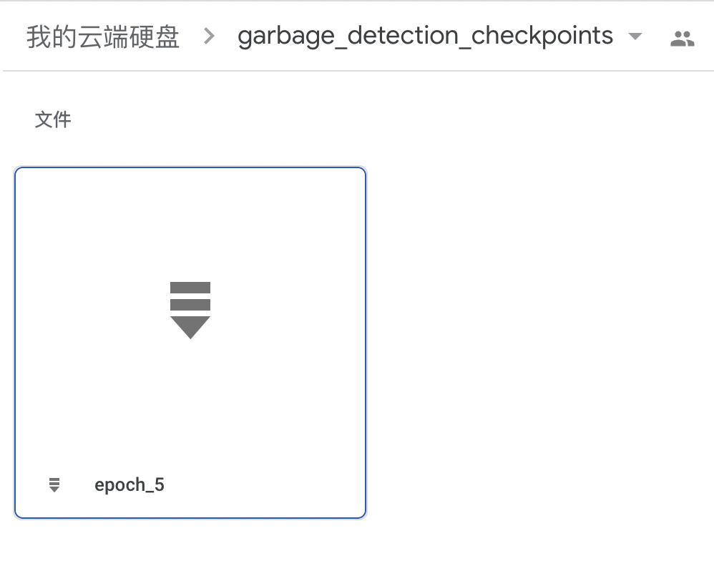

1. Create a folder inside app and put the checkpoints there
2. Edit the hard code path for loading checkpoints

